2-router OSPF practical 9.
OSPF Practical — 2 Routers
1. Topology
Create this in Packet Tracer:
PC1 ─── Switch ─── R1 ═════════ R2 ─── Switch ─── PC2
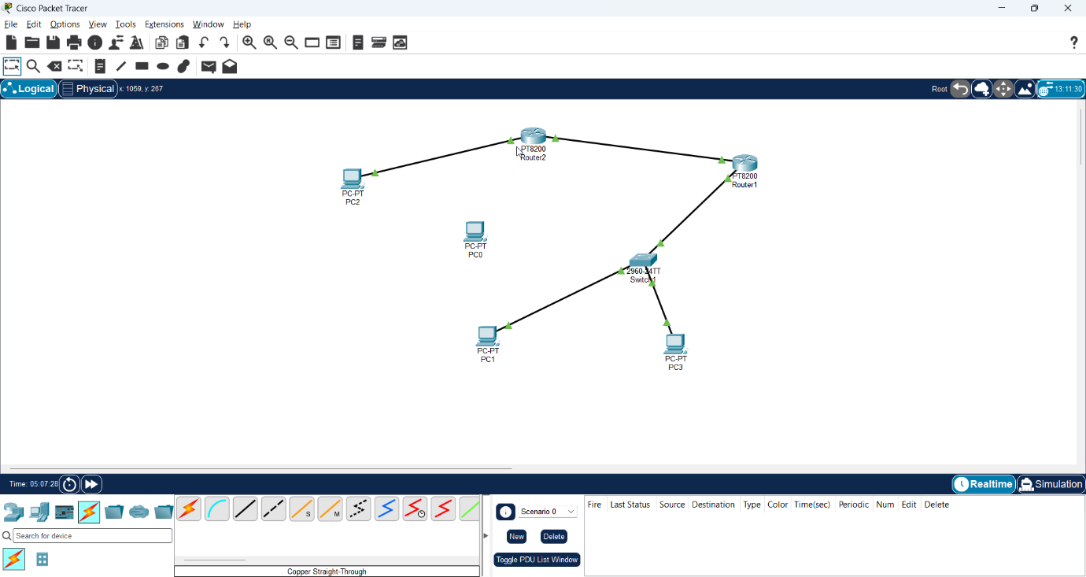
OSPF
You can actually omit the switches and connect the PCs directly to the routers if your PT-8200 topology permits it. For a standard demonstration, use switches.
Addressing
Device | Interface | IP Address | Network
PC1 | NIC | 192.168.1.10 | 192.168.1.0/24
R1 | G0/0/0 | 192.168.1.1 | 192.168.1.0/24
R1 | G0/0/1 | 10.0.0.1 | 10.0.0.0/30
R2 | G0/0/0 | 10.0.0.2 | 10.0.0.0/30
R2 | G0/0/1 | 192.168.2.1 | 192.168.2.0/24
PC2 | NIC | 192.168.2.10 | 192.168.2.0/24

The important concept is that the two LANs are different networks.
192.168.1.0/24 10.0.0.0/30 192.168.2.0/24

PC1 ─── R1 ───────────────────────── R2 ─── PC2
.1 .1 .2 .1

2. Configure PC1
Go to:
PC1 → Desktop → IP Configuration
Enter:
IP Address: 192.168.1.10
Subnet Mask: 255.255.255.0
Default Gateway: 192.168.1.1

3. Configure PC2
Enter:
IP Address: 192.168.2.10
Subnet Mask: 255.255.255.0
Default Gateway: 192.168.2.1

4. Configure R1
Click R1 → CLI.
Enter:
enable
configure terminal

interface GigabitEthernet0/0/0
ip address 192.168.1.1 255.255.255.0
no shutdown
exit

interface GigabitEthernet0/0/1
ip address 10.0.0.1 255.255.255.252
no shutdown
exit

end
Check:
show ip interface brief
You want:
GigabitEthernet0/0/0 192.168.1.1 up up
GigabitEthernet0/0/1 10.0.0.1 up up
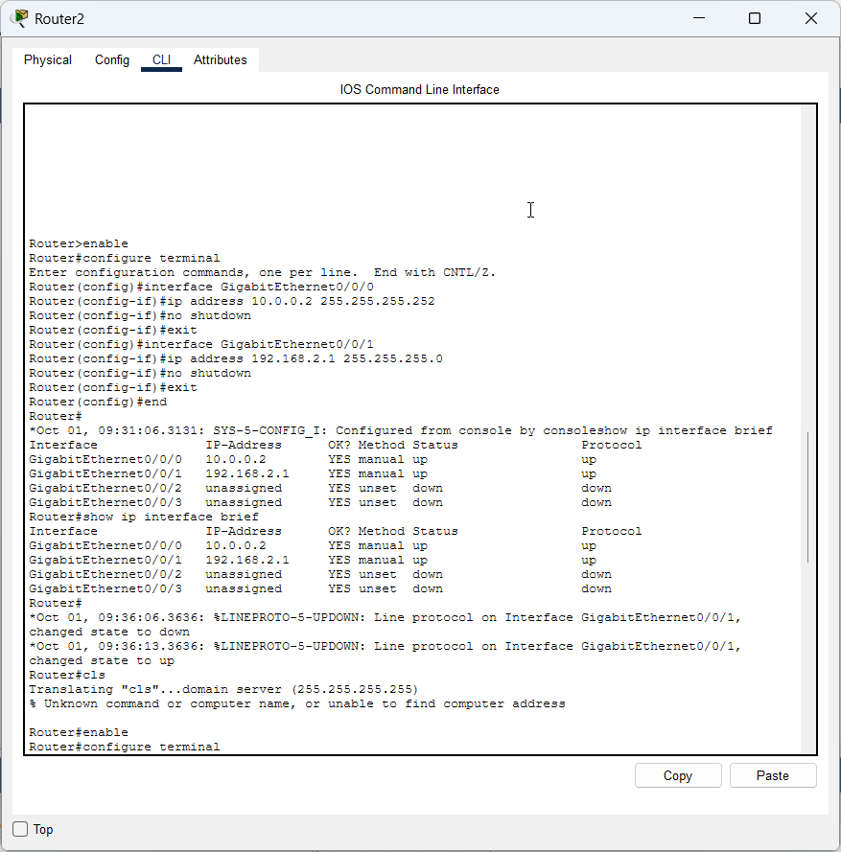

5. Configure R2
On R2:
enable
configure terminal
interface GigabitEthernet0/0/0
ip address 10.0.0.2 255.255.255.252
no shutdown
exit

interface GigabitEthernet0/0/1
ip address 192.168.2.1 255.255.255.0
no shutdown
exit

end
Check:
show ip interface brief
You should get:
GigabitEthernet0/0/0 10.0.0.2 up up
GigabitEthernet0/0/1 192.168.2.1 up up

6. Test the physical/IP connectivity
Before configuring OSPF, test the directly connected link.
From R1:
ping 10.0.0.2
It should work.
From R2:
ping 10.0.0.1
It should work.
Now try from PC1:
ping 192.168.2.10
It will not work yet.
That's expected.
Why?
R1 doesn't yet know how to reach:
192.168.2.0/24
And R2 doesn't know how to reach:
192.168.1.0/24
This is where OSPF comes in.

7. Configure OSPF on R1
On R1:
enable
configure terminal

router ospf 1
router-id 1.1.1.1
network 192.168.1.0 0.0.0.255 area 0
network 10.0.0.0 0.0.0.3 area 0

end
That's it.
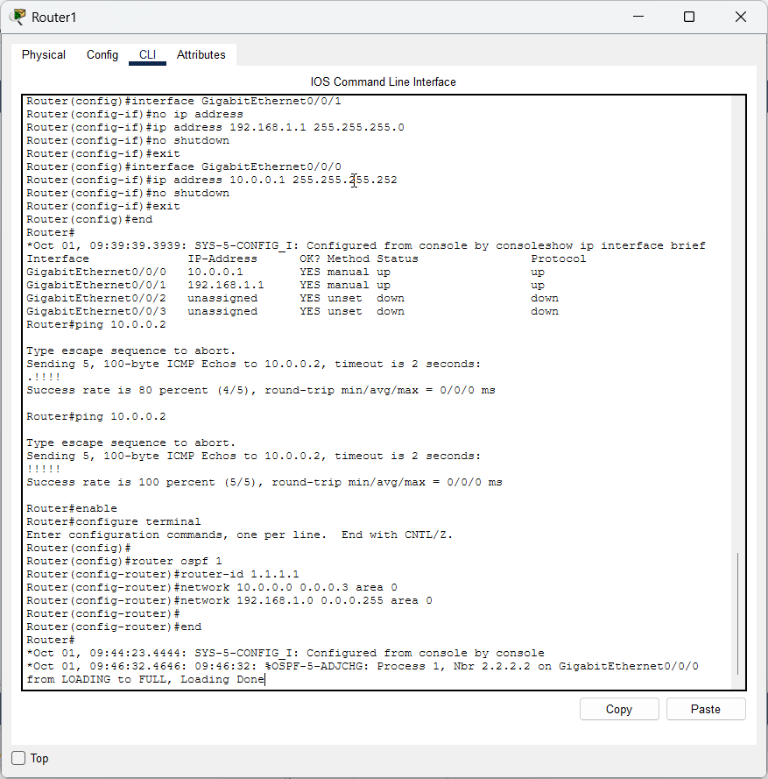

8. Configure OSPF on R2
On R2:
enable
configure terminal

router ospf 1
router-id 2.2.2.2
network 10.0.0.0 0.0.0.3 area 0
network 192.168.2.0 0.0.0.255 area 0

end
Wait a few seconds.
You may see a message similar to:
%OSPF-5-ADJCHG: Process 1, Nbr 1.1.1.1 on GigabitEthernet0/0/0 from LOADING to FULL
FULL is what you want.
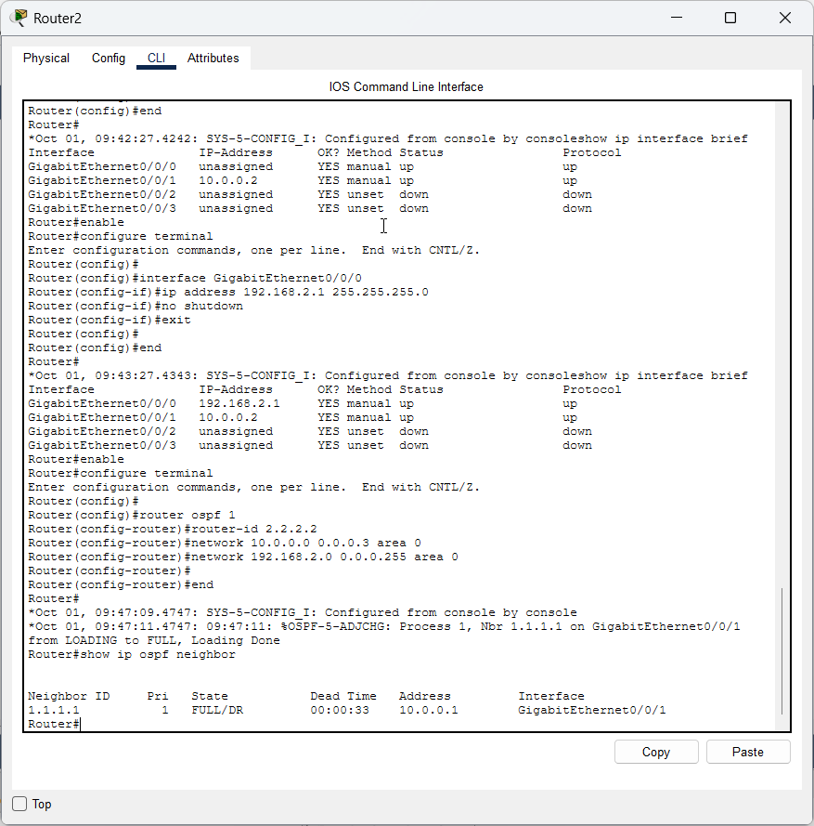

9. Check the OSPF neighbor
On R1:
show ip ospf neighbor
You should see something similar to:
Neighbor ID State
2.2.2.2 FULL
On R2:
show ip ospf neighbor
You should see:
Neighbor ID State
1.1.1.1 FULL
This is an important observation for your practical record:
R1 and R2 have successfully established an OSPF neighbor adjacency.

10. Check the routing table
On R1:
show ip route
You should find:
O 192.168.2.0/24
The O means:
This route was learned through OSPF.
On R2:
show ip route
You should find:
O 192.168.1.0/24
This is the key result of the practical.

11. Now perform the final test
Go to PC1 → Desktop → Command Prompt.
Run:
ping 192.168.2.10
You should now receive:
Reply from 192.168.2.10
Reply from 192.168.2.10
Reply from 192.168.2.10
Reply from 192.168.2.10
Your OSPF configuration is working.
The packet is travelling:
PC1
│
│ 192.168.1.10
↓
R1
│
│ 10.0.0.1 → 10.0.0.2
↓
R2
│
│ 192.168.2.1
↓
PC2

12. Demonstrate the route
From PC1:
tracert 192.168.2.10
You should see the traffic going through R1 and R2.

13. Commands to write in their practical record
Configuration
router ospf 1
router-id 1.1.1.1
network 192.168.1.0 0.0.0.255 area 0
network 10.0.0.0 0.0.0.3 area 0
and on R2:
router ospf 1
router-id 2.2.2.2
network 10.0.0.0 0.0.0.3 area 0
network 192.168.2.0 0.0.0.255 area 0
Verification
show ip interface brief
show ip ospf neighbor
show ip route
show ip route ospf
show ip protocols
Connectivity
ping 10.0.0.2
ping 192.168.2.10
tracert 192.168.2.10

network 192.168.1.0 0.0.0.255 area 0
means:
"Enable OSPF on the interface whose IP belongs to the 192.168.1.0/24 network and advertise that network in Area 0."
And:
network 10.0.0.0 0.0.0.3 area 0
means:
"Enable OSPF on the R1–R2 link and advertise that network in Area 0."
The complete practical in one picture
10.0.0.0/30
.1 .2
┌───┐ ┌───┐
PC1────│ R1│══════════════│ R2│────PC2
└───┘ OSPF └───┘
.1 .1
│ │
192.168.1.0/24 192.168.2.0/24
│ │
192.168.1.10 192.168.2.10
Goal: PC1 → ping 192.168.2.10 → successful.

OSPF is working correctly.
The most important line is:
O 192.168.2.0/24 [110/2] via 10.0.0.2, GigabitEthernet0/0/0
Let's understand it
O
= Route learned through OSPF.
192.168.2.0/24
= The LAN behind R2.
[110/2]
- 110 = OSPF administrative distance
- 2 = OSPF metric/cost
via 10.0.0.2
= R1 reaches that network through R2.
So R1 has automatically learned:
"To reach 192.168.2.0/24, send the packet to 10.0.0.2."
That's the core purpose of this practical.

1. Check R2's routing table
You should also run on R2:
show ip route
You should see something like:
O 192.168.1.0/24 [110/2] via 10.0.0.1
If you see that, both routers have learned each other's LAN.

2. Check PC1 configuration
On PC1:
Desktop → IP Configuration
Make sure:
IP Address: 192.168.1.10
Subnet Mask: 255.255.255.0
Default Gateway: 192.168.1.1
3. Check PC2
IP Address: 192.168.2.10
Subnet Mask: 255.255.255.0
Default Gateway: 192.168.2.1

4. Final test — PC1 → PC2
On PC1:
Desktop → Command Prompt
Run:
ping 192.168.2.10
You should get:
Reply from 192.168.2.10
Reply from 192.168.2.10
Reply from 192.168.2.10
Reply from 192.168.2.10
If the first ping fails
Don't worry if you initially get something like:
Request timed out.
Reply from 192.168.2.10
Reply from 192.168.2.10
The first packet can be lost while ARP resolution takes place. Run the ping again.

1. Interface configuration
R1 → 10.0.0.1
R2 → 10.0.0.2
2. Basic connectivity
R1#ping 10.0.0.2
!!!!!
3. OSPF configuration
router ospf 1
router-id ...
network ... area 0
4. OSPF neighbor formation
FULL/DR
5. Dynamic route learning
O 192.168.2.0/24
6. End-to-end connectivity
PC1 → R1 → R2 → PC2

Run:
show ip route ospf
On R1, it should give you the cleanest possible evidence that OSPF has learned the remote network:
O 192.168.2.0/24 [110/2] via 10.0.0.2
You can take a screenshot of:
- show ip ospf neighbor
- show ip route ospf
- Successful ping 192.168.2.10
